CS 380

Exercise 6

My repository for this class is under CS 380 – Computer Networks

<https://github.com/jarodNakamoto/College-CS-Courses.git>

Setup

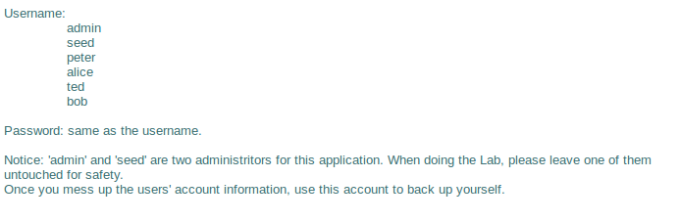

SQL Injection in User Authentication

Passwordless Ted

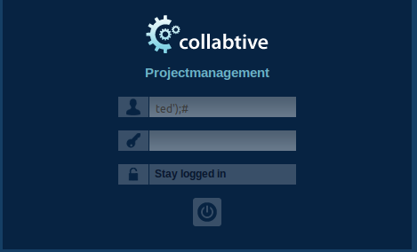

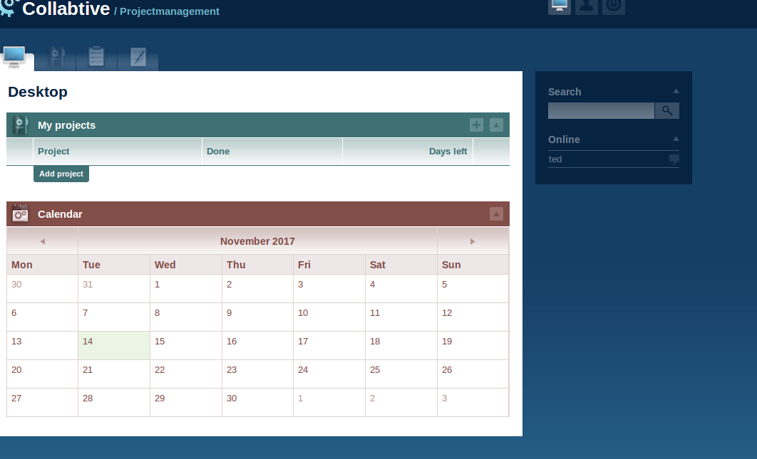

Passwordless Admin

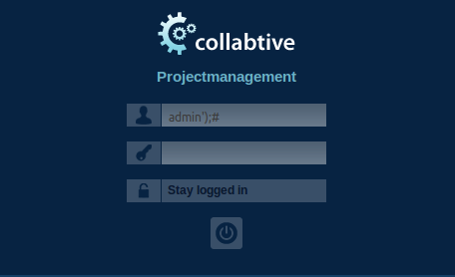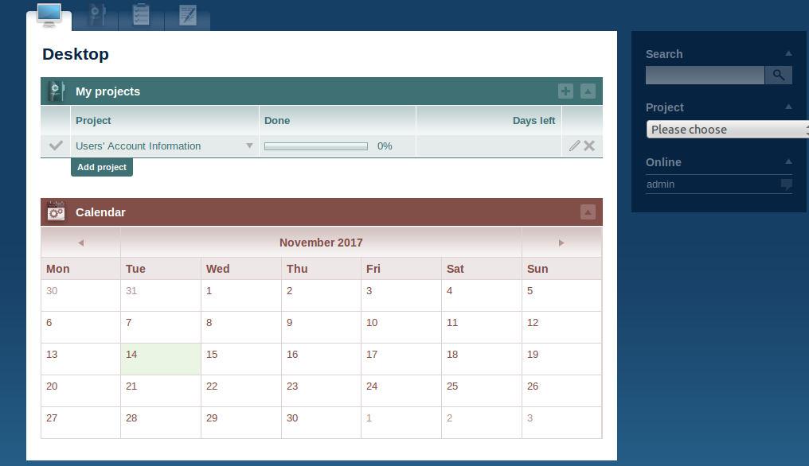

Blank User  
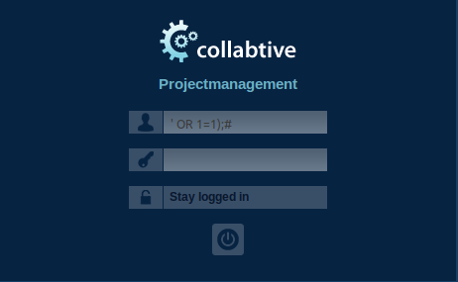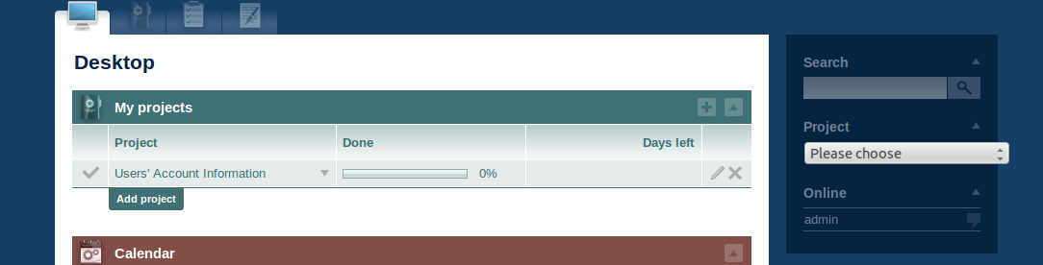

Like when logging in with ted and admin, when logging in with a blank user, the website does not require a password. Additionally, it thinks that you are the admin and there is no change in functionality as we can still access the project and the user passwords. 